  This Photo by Unknown Author is licensed under CC BY-NC | 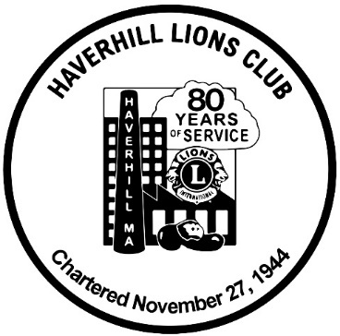 | This Photo by Unknown Author is licensed under CC BY-NC

HAVERHILL LIONS CLUB
Presents:
BREAKFAST WITH SANTA
Saturday, December 6, 2025
8:30 am to 11:30 am
Maria's Family Restaurant
81-83 Essex Street, Haverhill, MA

$5.00 per person (includes entry & breakfast)

Bring Your Camera and Take a Picture with Santa!

TICKETS WILL BE SOLD AT THE DOOR!
We accept:
Visa, Mastercard, American Express and Discover

For more information, please call:
978-374-2268
Or visit www.HaverhillLionsClub.org

All proceeds to benefit Haverhill Lions Club Charities.

Please bring gently used kids’ and adults’ winter coats and
jackets for the Coats for Kids drive. No vests or fleece. Thanks!

